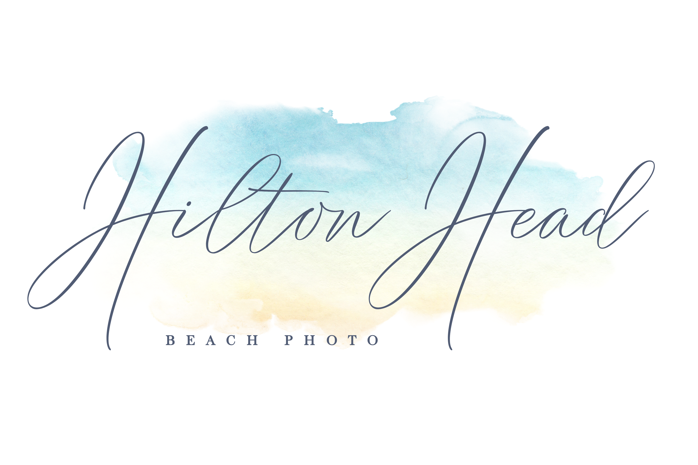
Portrait Pricing 2023

Collections:
"Bronze Collection" (10 5x7, 1 8-Mini's Wallet size, 2 8x10, 2 11x14, 1 16x20)
$549
"Silver Collection" (10 5x7, 1 8-Mini's Wallet size, 2 8x10, 2 11x14, 1 16x20, 1 20x30)
$639
"Gold Collection" ( 10 5x7, 1 8-Mini's Wallet size, 2 8x10, 2 11x14, 1 16x20, 1 16x20 Gallery Wrap/Canvas, high resolution digitals for download)
$959
"Platinum Collection" (5 5x7, 1 8-Mini's Wallet size, 2 8x10, 2 11x14, 1 20x24 Gallery Wrap/Canvas + Custom 10x10 Photo Book with your favorite pictures of the session, high resolution digitals for download)
$1199
"Diamond Collection" (5 5x7, 2 8x10, 1 11x14 mounted on Styrene with Lustre coating, 1 16x20 Standout with Lustre coating, 1 20x30 Canvas/Gallery Wrap + 10x10 Custum Photo Album with all your favorite pictures of the session, high resolution digitals for download)
$1499

A la carte:

Professional prints on metallic paper:
4x6 $19
5x7 $25
Wallet size/8 Mini's (same picture) $35
8x10 $39
11x14 $69
16x20 $149
20x30 $249
30x40 $349

Canvas Gallery Wrap 8x10 $199
Canvas Gallery Wrap 11x14 $249
Canvas Gallery Wrap 16x20 $399
Canvas Gallery Wrap 20x30 $549
Canvas Gallery Wrap 30x40 $649

Custom designed 20 pages/40 sides 10x10 layflat (not bending pages) Photo Book with all your favorite pictures of the session on gloss or pearl paper and with custom photo cover $499

Custom designed 20 pages/40 sides 10x10 layflat Photo Album with all your favorite pictures of the session on metallic paper and with custom photo cover $799

Custom designed greeting/announcement cards 5x7 double sided
25 cards - $59
50 cards - $99
75 cards - $139
100 cards - $179
Custom designed 5x7 folded cards
25 cards - $89
50 cards - $139
Please request higher quantities.

More print and product sizes available upon request.

All prices are excluding 6% South Carolina Sales Tax.

Prices subject to change without notice.

